**My Fitness App**

**Outline**

**My Fitness App** is a web-based health tracker that allows users to log workouts, meals, and track timers for exercises. Users can create accounts, log in, and view or search through workouts by all users, add personal nutrition entries for themselves as well as personal workouts. Their progress is tracked based on their daily. The app is built using **Node.js**, **Express.js**, and **EJS** for dynamic server-side rendering, with **MySQL** as the backend database. It emphasizes usability, allowing users to track fitness progress efficiently and review past entries. The code is organized into routes, views, and configuration modules, making the application modular and easy to maintain.

**Architecture**

The **application tier**is built using **Node.js and Express**, which handles routing, authentication, and business logic. Each route is modularized into files like routes/workouts.js, routes/meals.js, and routes/timers.js. **EJS** templates dynamically render views on the server side, populating pages with user-specific data from the database. **Static assets** like CSS reside in the public folder and are served to the browser. The **data tier** uses **MySQL**to store users, workouts, and meals. The db.js module establishes a connection pool and executes queries for CRUD operations. Environment variables stored in .env secure sensitive information like database credentials and application base paths. This architecture allows a **responsive and secure user experience**, separating frontend, backend, and data storage concerns clearly.

**Data Model**

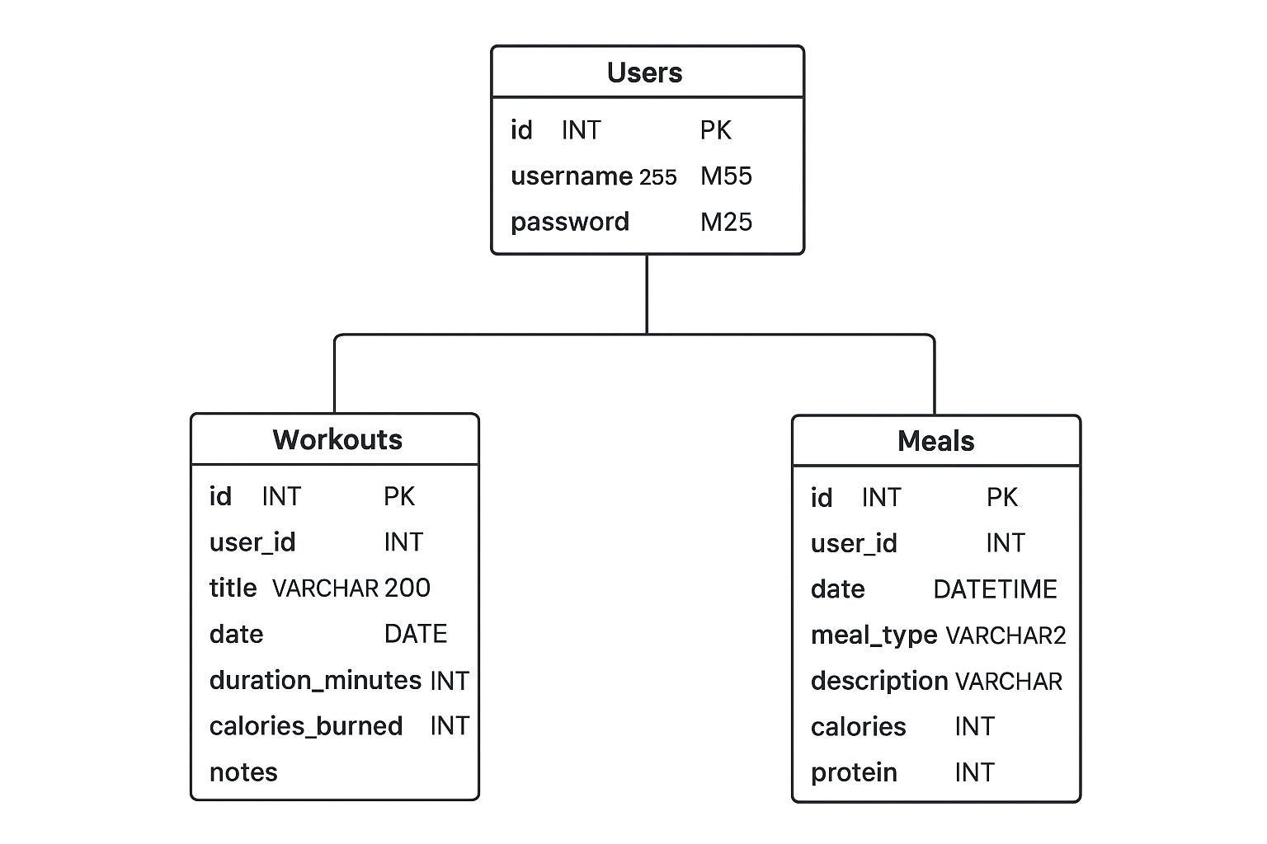

The application uses a MySQL relational database named health to store user accounts, workouts, and meals. All tables are linked through foreign keys to the users table, ensuring that all entries belong to a valid user.

**Tables and Relationships:**

1. **Users**  
   Stores account information for each registered user:
   * id (INT, PK, AUTO_INCREMENT): Unique identifier for each user
   * username (VARCHAR(50), UNIQUE): Display name used for login
   * password (VARCHAR(255)): Hashed password for authentication
2. **Workouts**  
   Records workout sessions performed by users:
   * id (INT, PK, AUTO_INCREMENT): Unique workout ID
   * user_id (INT, FK → users.id): Links workout to a user
   * title (VARCHAR(200)): Name of the workout
   * date (DATE): Date of the workout
   * duration_minutes (INT): Duration of workout in minutes
   * calories_burned (INT): Estimated calories burned
   * notes (TEXT): Optional notes about the session
3. **Meals**  
   Tracks nutritional intake:
   * id (INT, PK, AUTO_INCREMENT): Unique meal entry ID
   * user_id (INT, FK → users.id): Links meal to a user
   * date (DATETIME, DEFAULT CURRENT_TIMESTAMP): Timestamp of meal entry
   * meal_type (VARCHAR(20)): Type of meal (breakfast, lunch, dinner, snack)
   * description (VARCHAR(255)): Description of the meal
   * calories (INT): Total calories
   * protein (INT): Protein content (grams)
   * carbs (INT): Carbohydrate content (grams)
   * fats (INT): Fat content (grams)

**Relationships:**

* One-to-many relationship from Users → Workouts and Users → Meals.
* The ON DELETE SET NULL constraint in the workouts table ensures that if a user is deleted, their workouts are not lost but the user_id is set to NULL.
* Foreign key constraints maintain referential integrity, preventing orphaned entries.

**User Functionality**

**Home**

Displays a summary of logged workouts, meals, and timers. Users can navigate to specific sections: view workouts, track meals, or set timers.

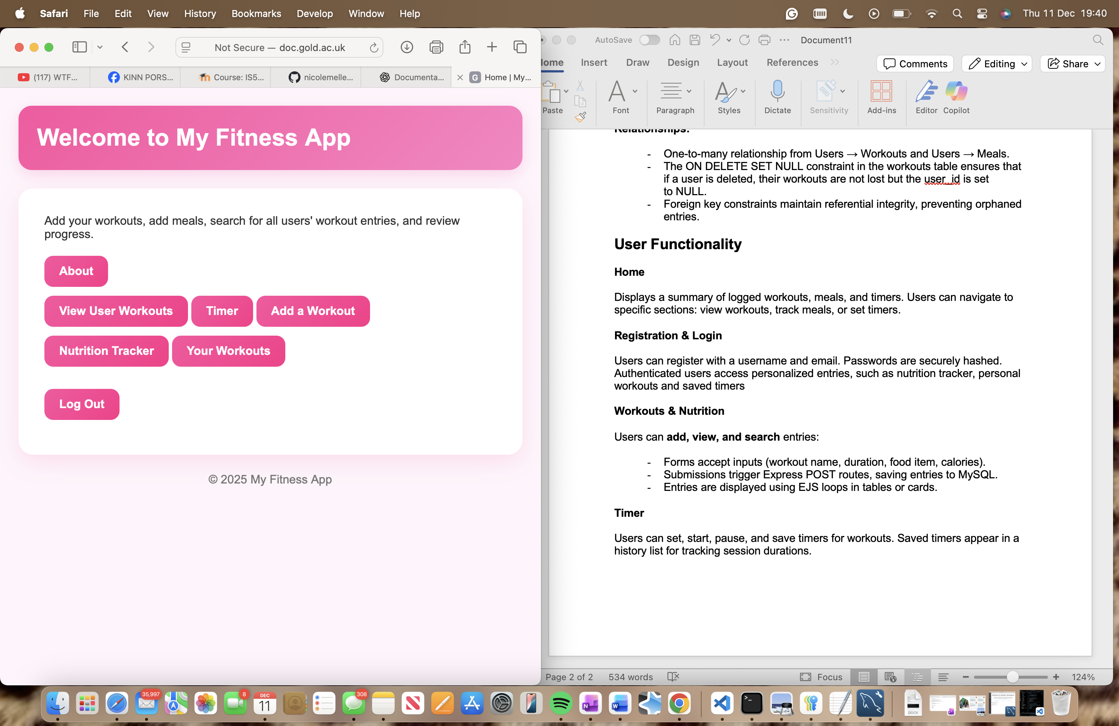

**Registration & Login**

Users can register with a username and email. Passwords are securely hashed. Authenticated users access personalized entries, such as nutrition tracker, personal workouts and saved timers.

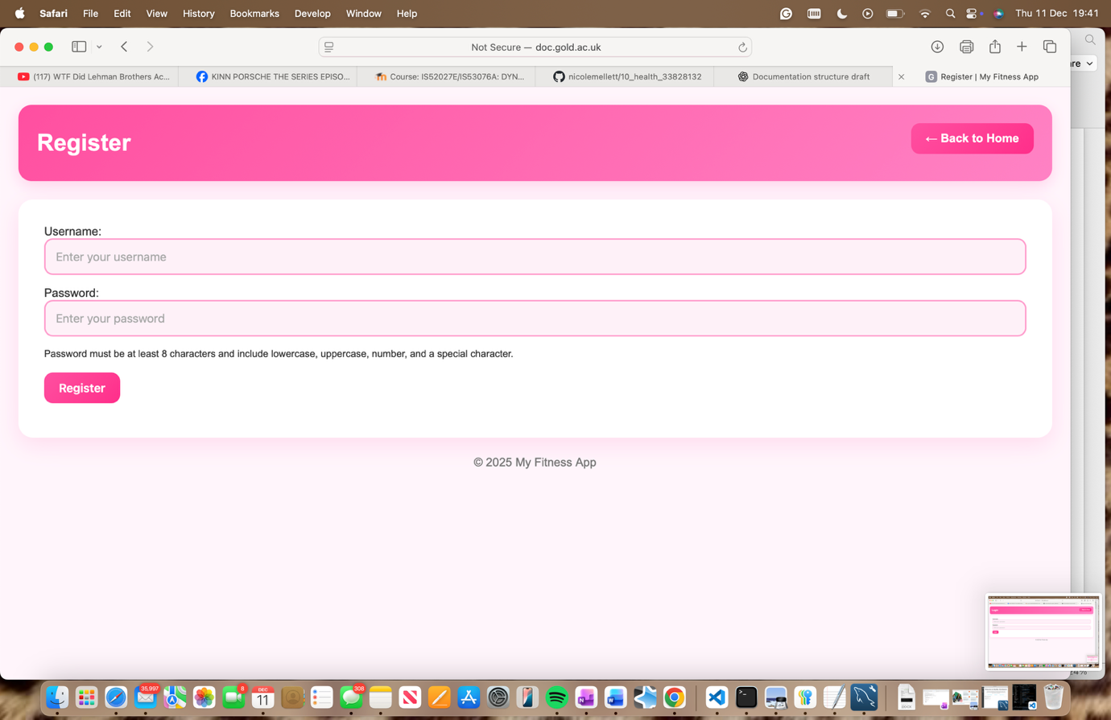

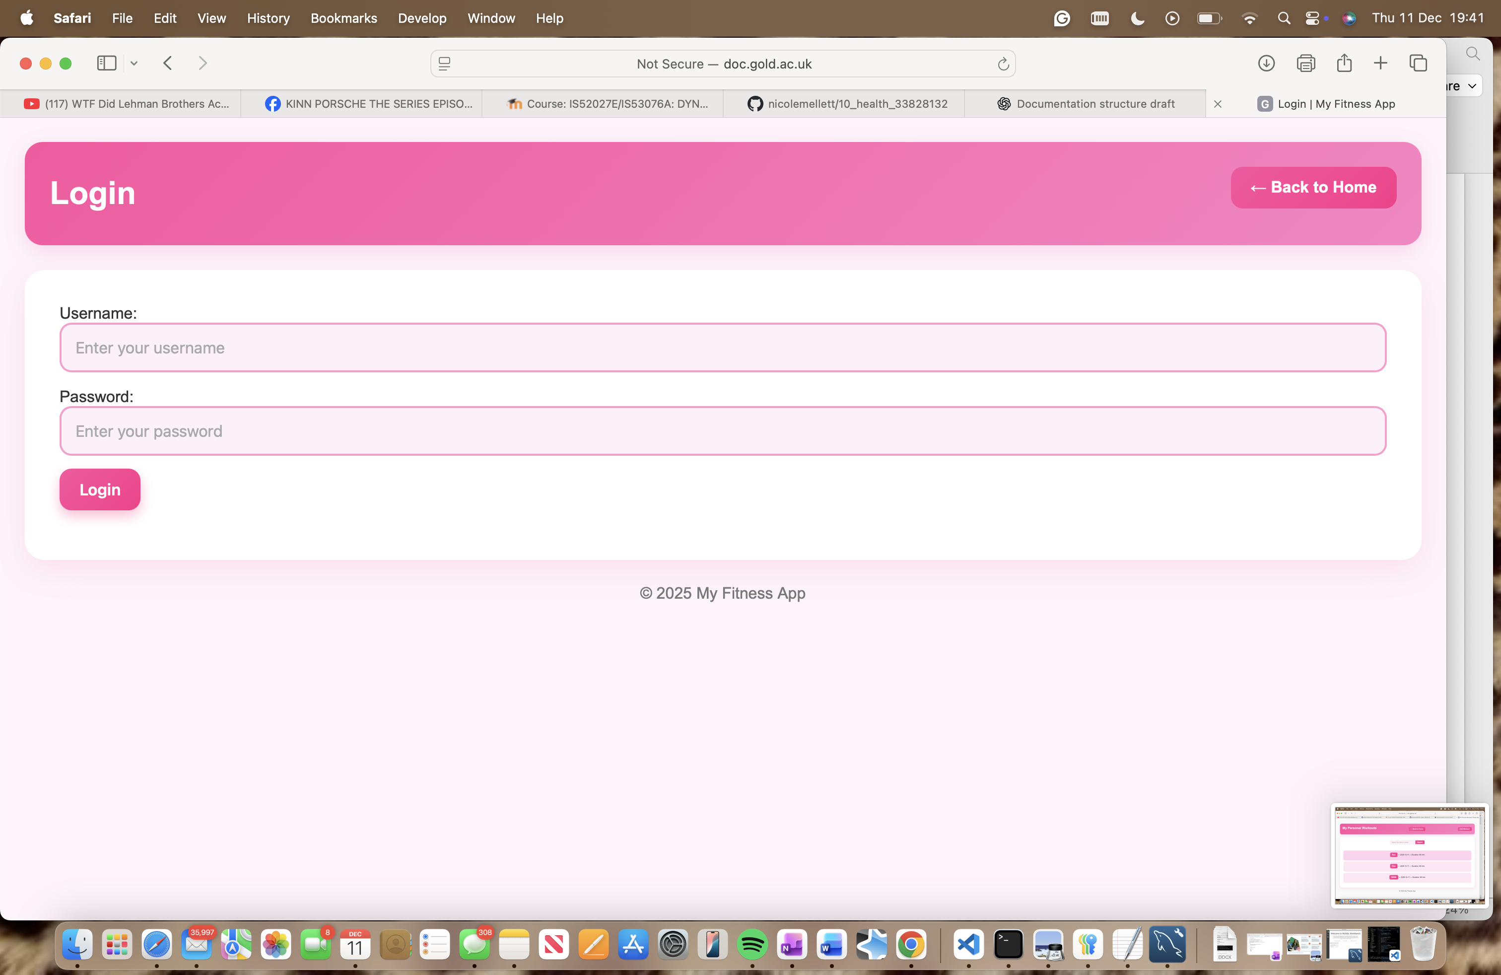

**About**

About page explaining features of the fitness app and the apps mission.

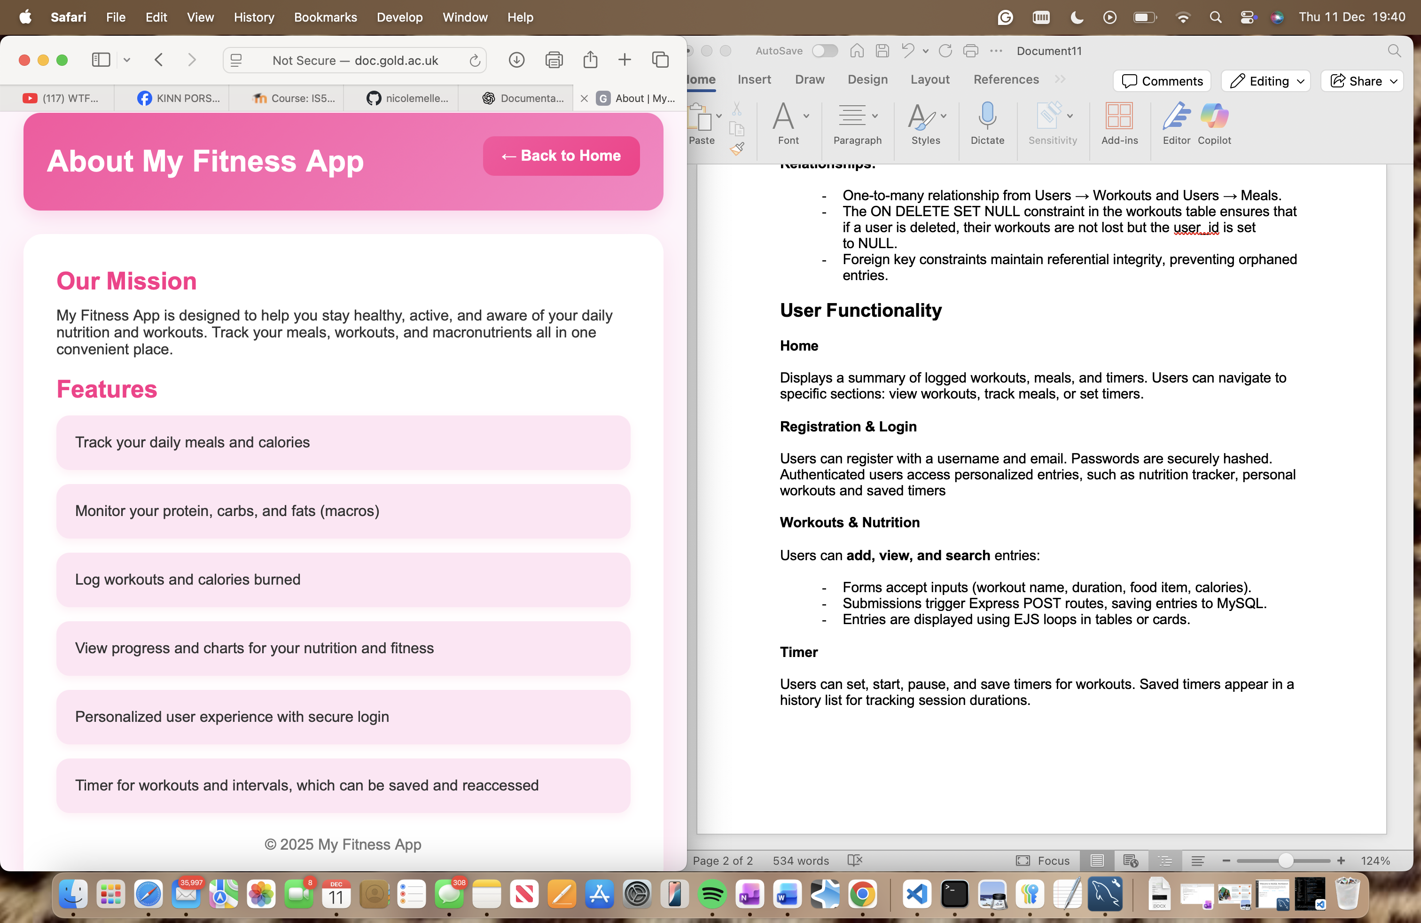

**Workouts**

Users can **add, view, and search** entries in main workouts, which shows all users inputs or personal, which is just their own workouts inputted.

* + Forms accept inputs (workout name, duration, food item, calories).
  + Submissions trigger Express POST routes, saving entries to MySQL.
  + Entries are displayed using EJS loops in tables or cards.
  + Workouts are displayed in **tables or cards** for easy visualization.
  + Search functionality allows filtering workouts by date or keyword.

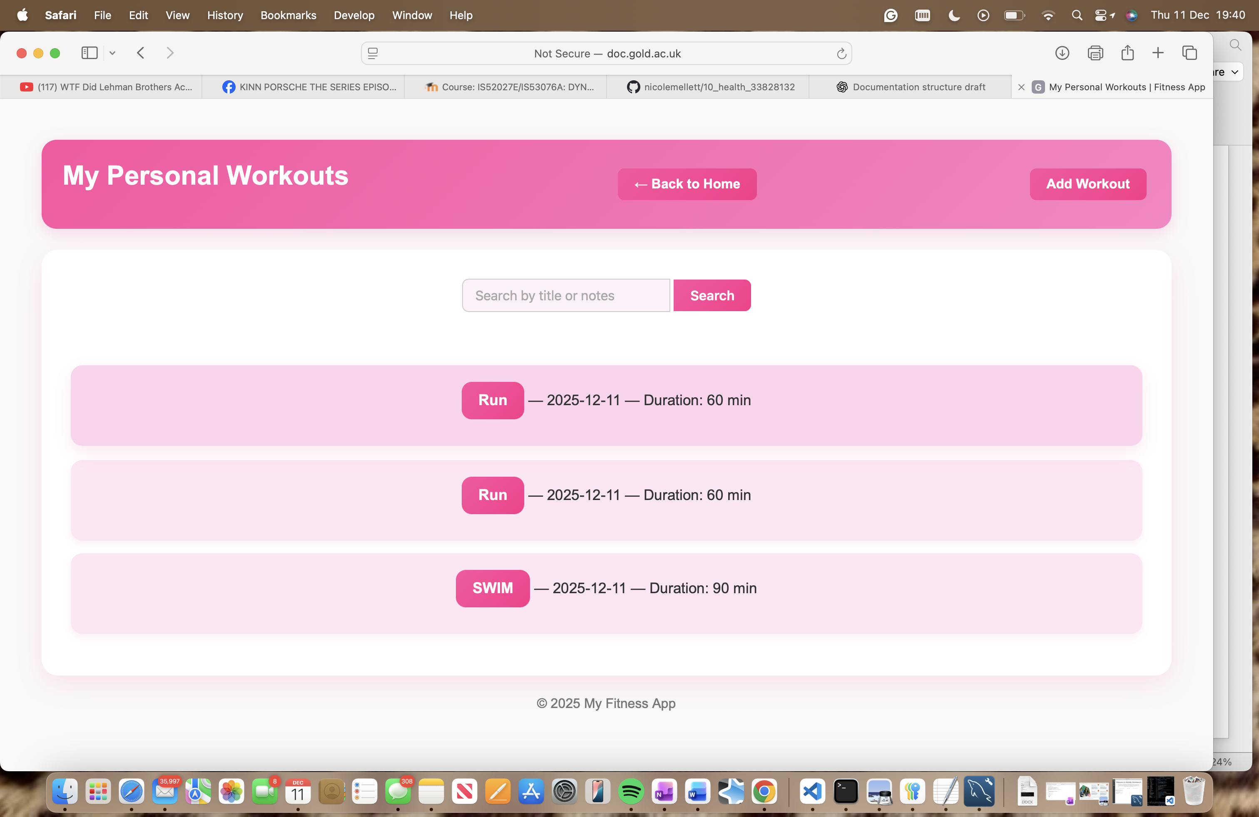

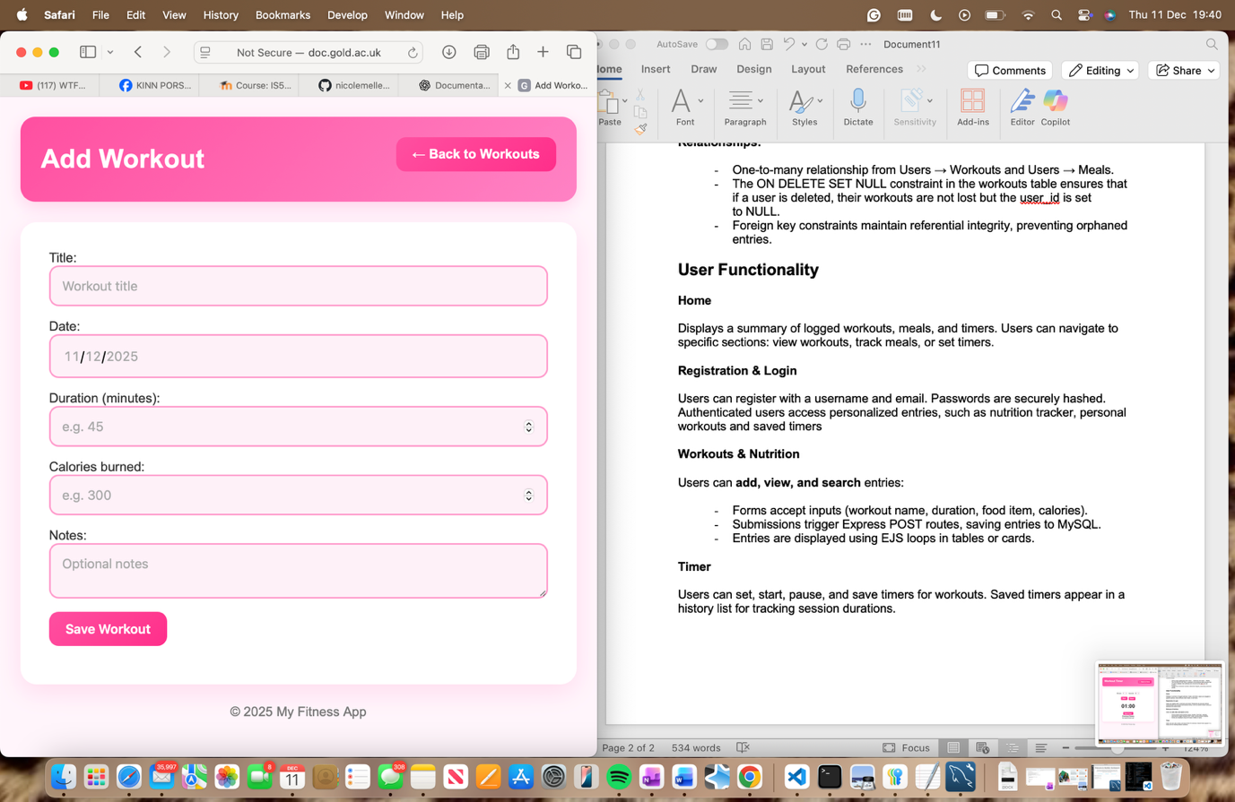

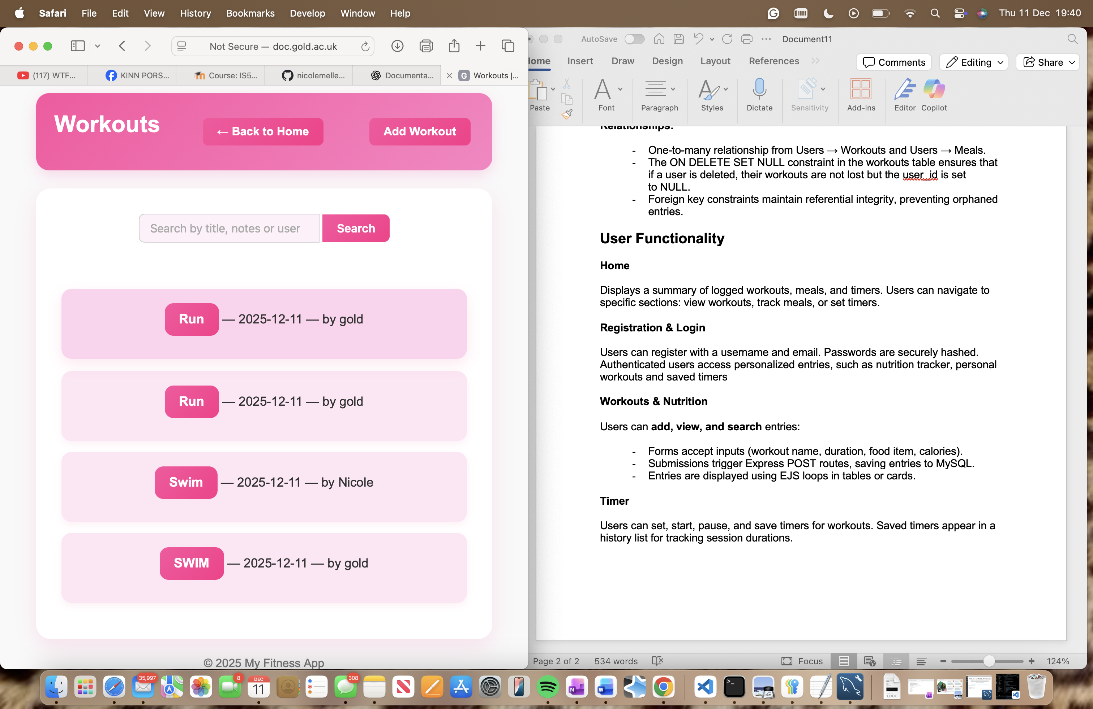

**Nutrition Tracker**

Users can log meals, specifying type (breakfast, lunch, dinner, snack), description, and nutritional values (calories, protein, carbs, fats). Entries are displayed in chronological order with totals and summaries. Macronutrients are stored using a diagram

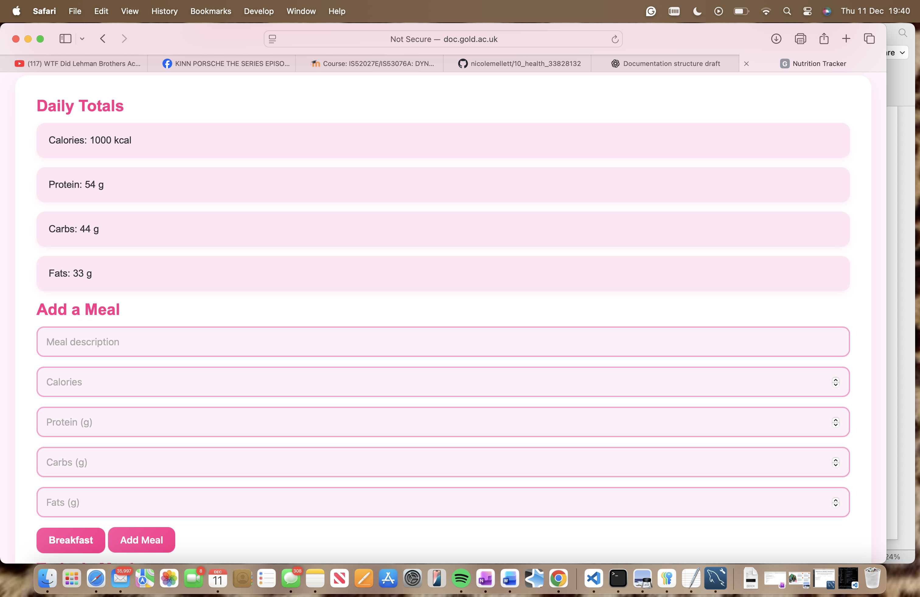

**Timer**

Users can set, start, pause, and save timers for workouts. Saved timers appear in a history list for tracking session durations, if users are logged in.

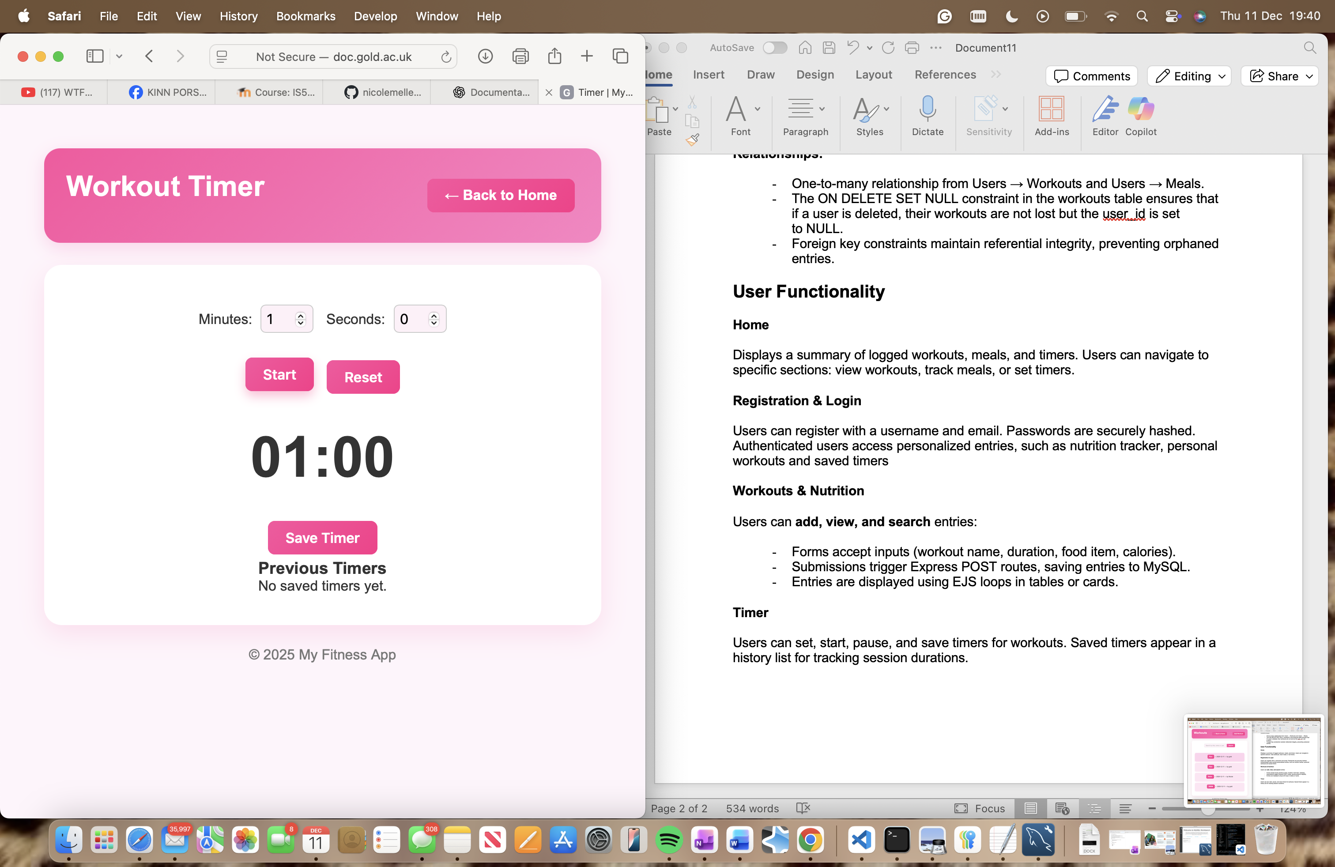

**Navigation and Layout**

The app uses a consistent header and navigation bar across pages for easy access to key features. EJS templates include partials for headers, footers, and repeated UI components.

**AI Declaration**

I used AI to help with errors, mainly relating to trying to fix the MySql database on the virtual server.